250 grams High Quality Natural White Nest A

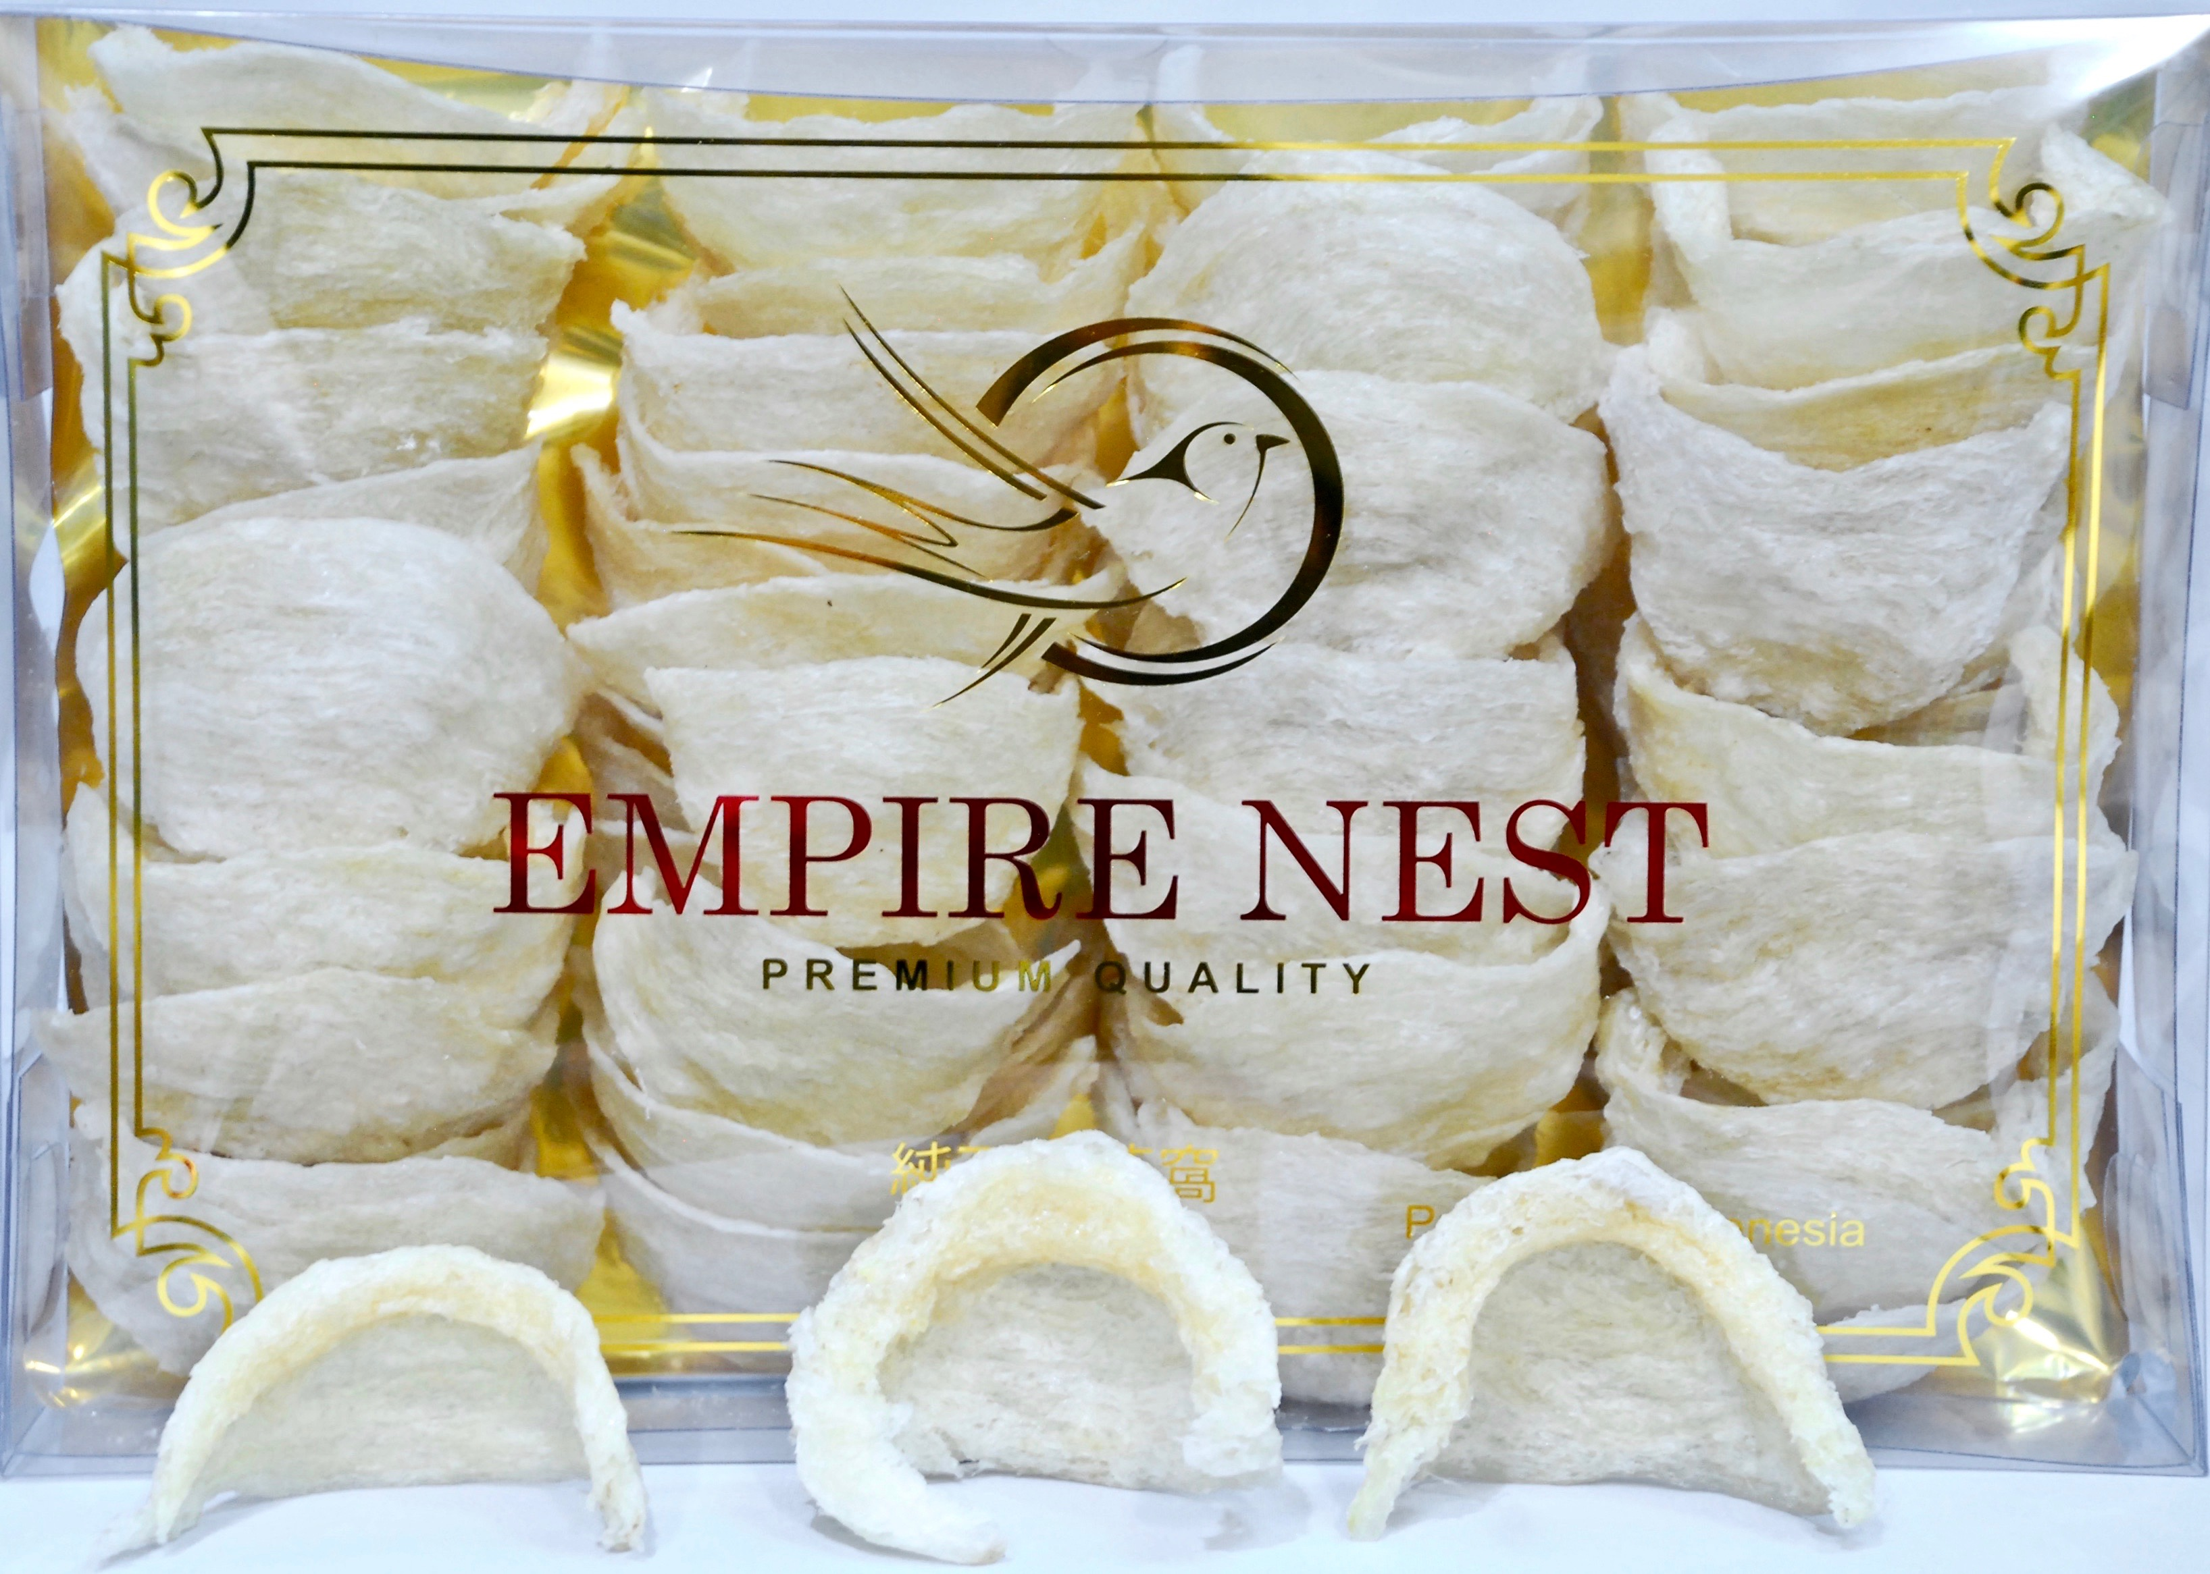

250 grams High Quality Natural White Nest AA

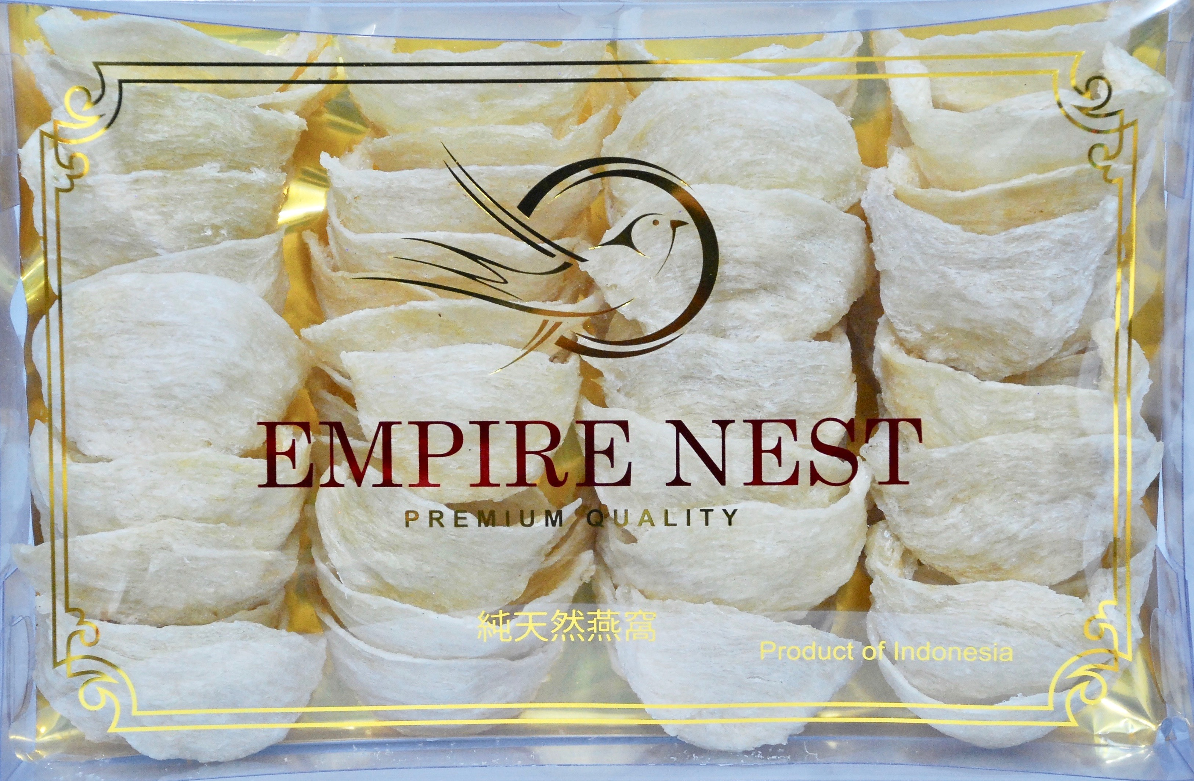

250 grams High Quality Natural White Nest AAA

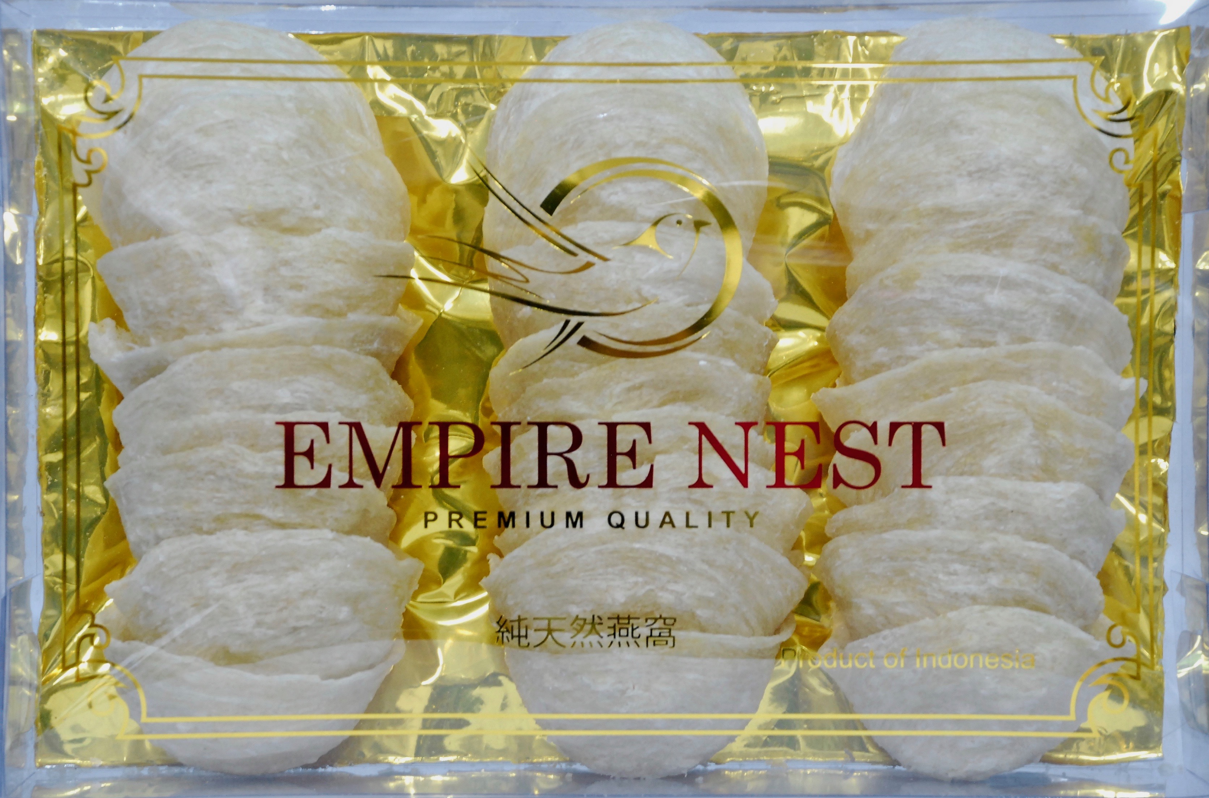

250 grams High Quality Natural White Nest AAAA

